APPLICATION GATEWAY

- Application gateway is nothing but a Regional Load Balancer.
- It Routes Path/URL based routing.
- It works on OSI layer 7 called application layer.
- It supports both HTTP and HTTPS based applications.

APPLICATION GATEWAY

HOMEPOOL
PERSONAL

/VAR/WWW/HTML /PERSONAL

VNET-1
SUBNET-1: VM-1 + VM2
SUBNE-2: APPPLICATION GATEWAY
1.connect VM-1 by using ssh and browse on browser by using public IP.
2. Next for second machine we have to add path called /personal. When we browse second machine on browser by using public IP with /personal the result needs to get.

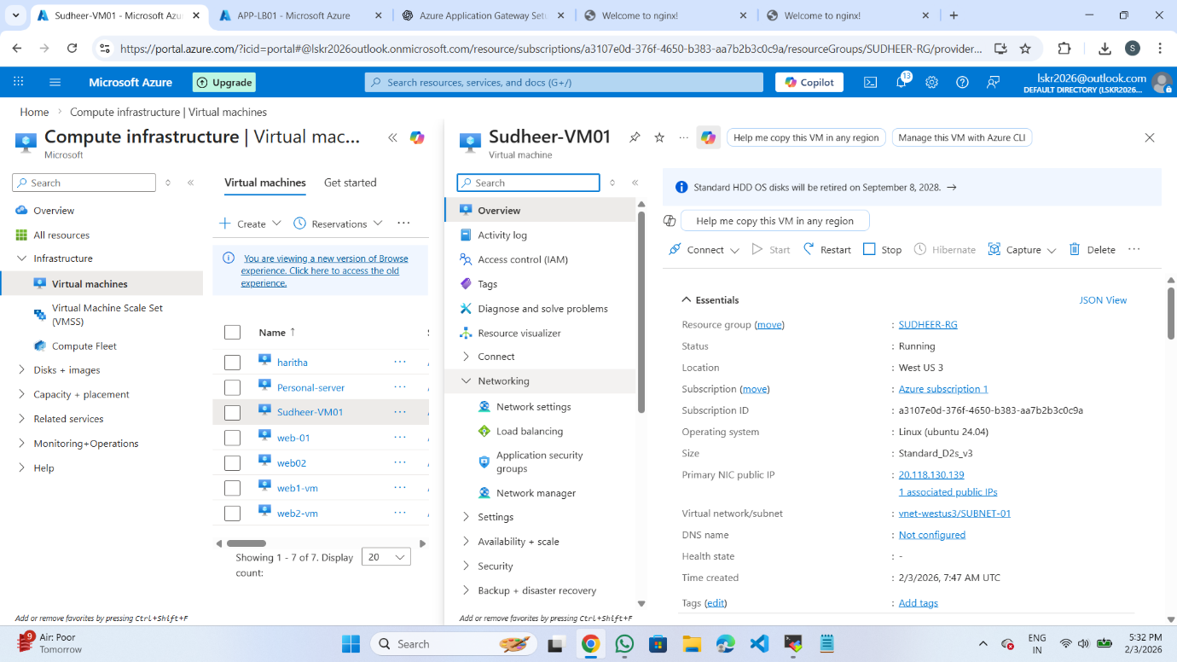

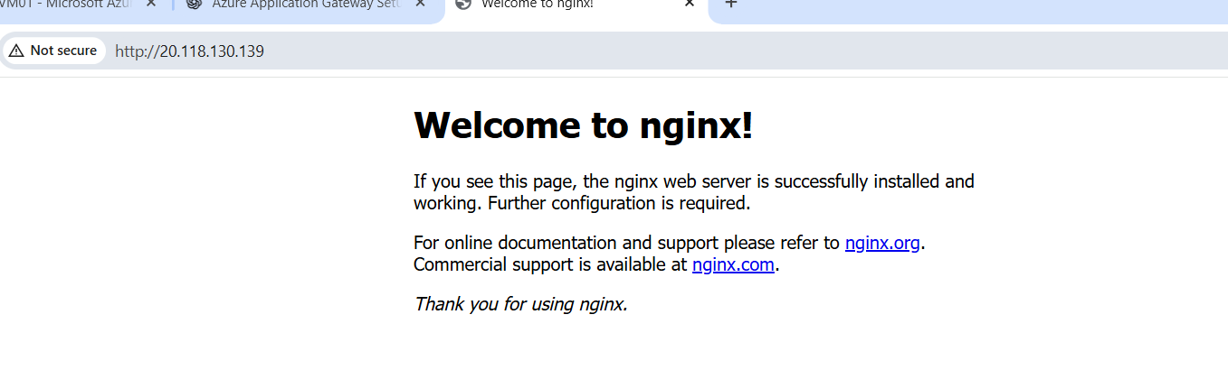
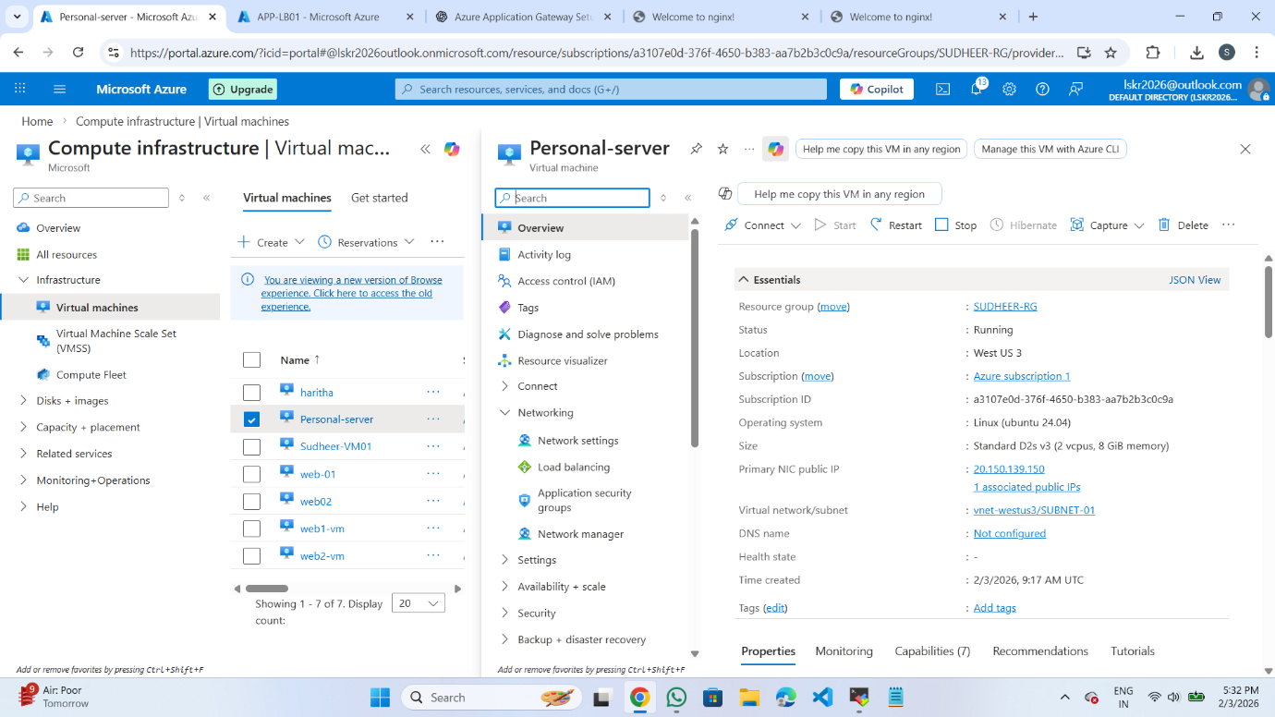


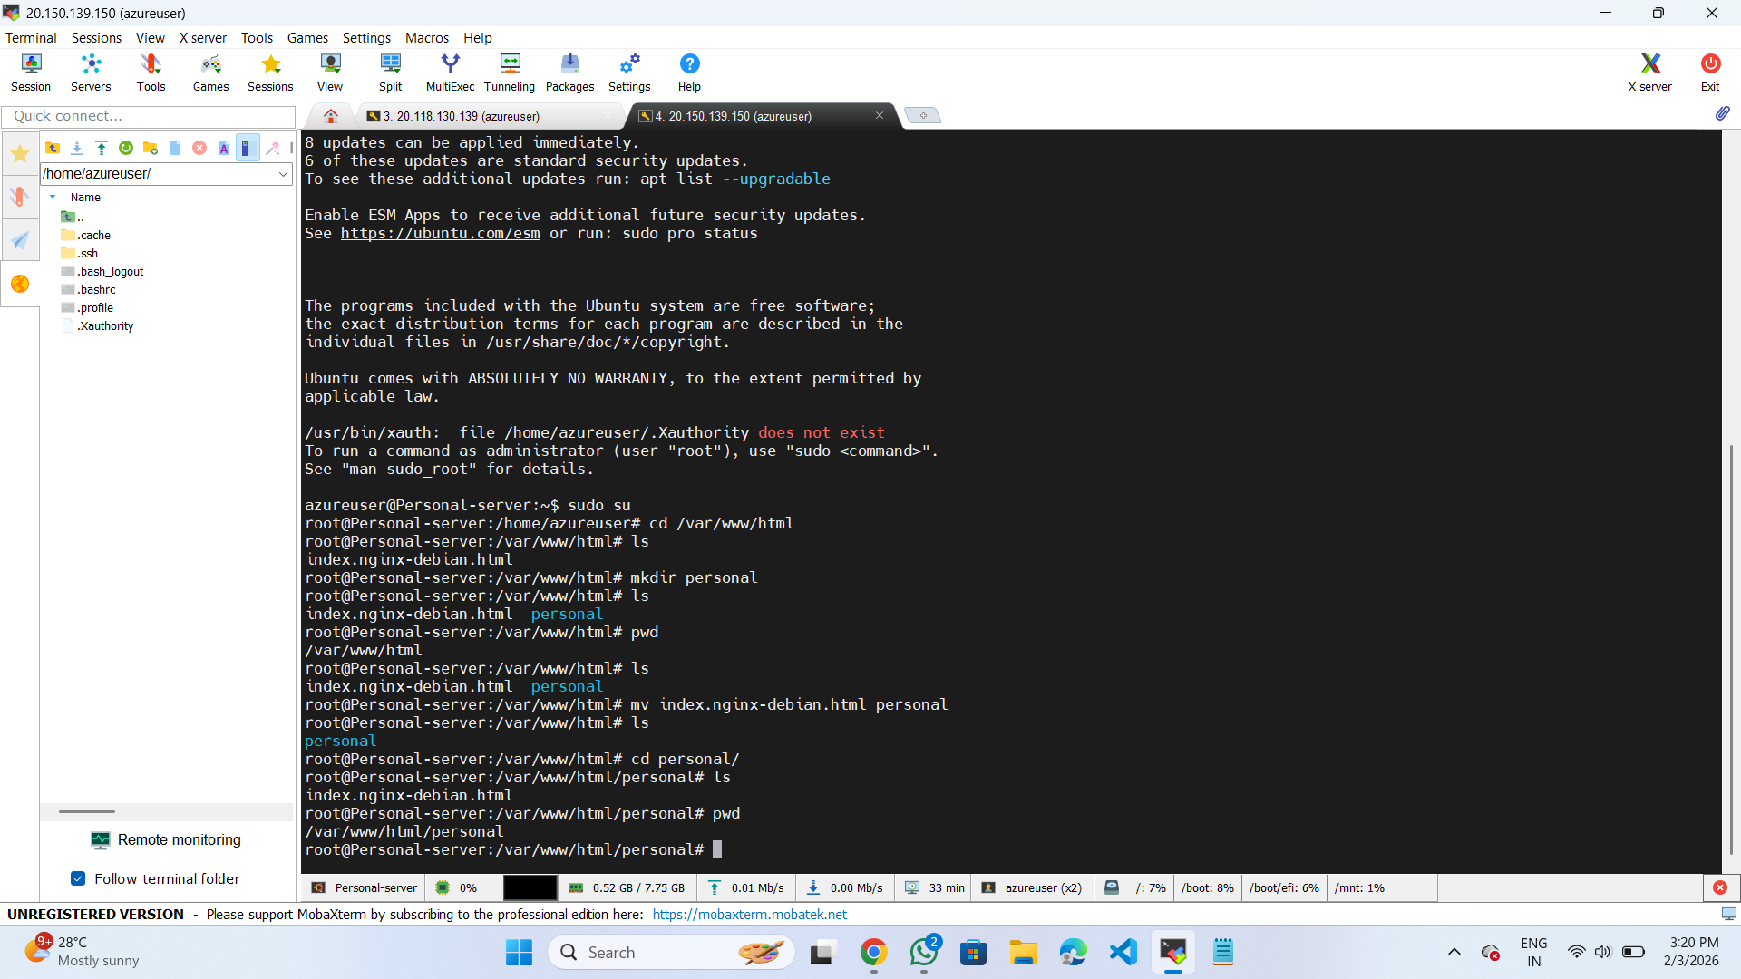

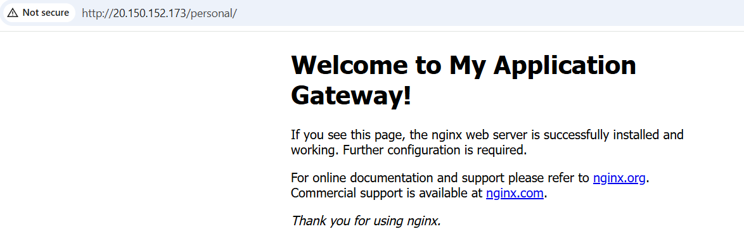
- When I browse with second vm public IP/personal the result has not get. Next I have added /personal and browse with public ip/personal the result has shown in the above figure.

- Next I have created a application gateway as shown in figure below.
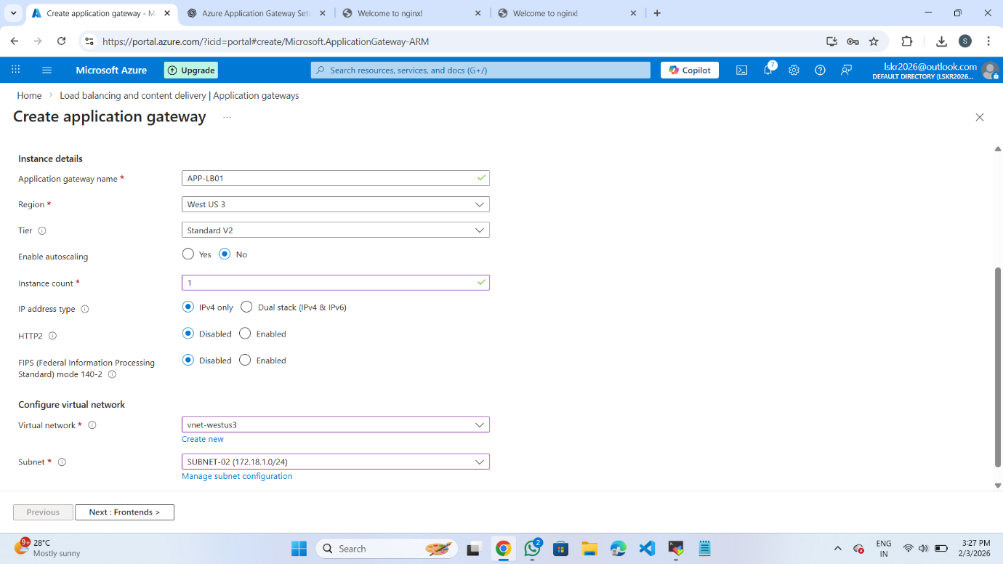
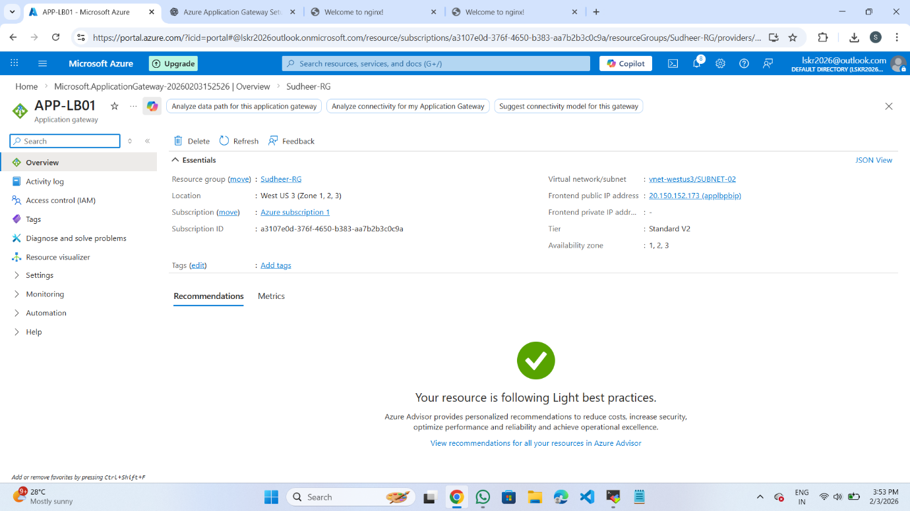

1.After creating application gateway. In application gateway I have configured some steps called backend pools, backend steps, listeners, frontend ip, rules,Health probes etc. all this images are mentioned below

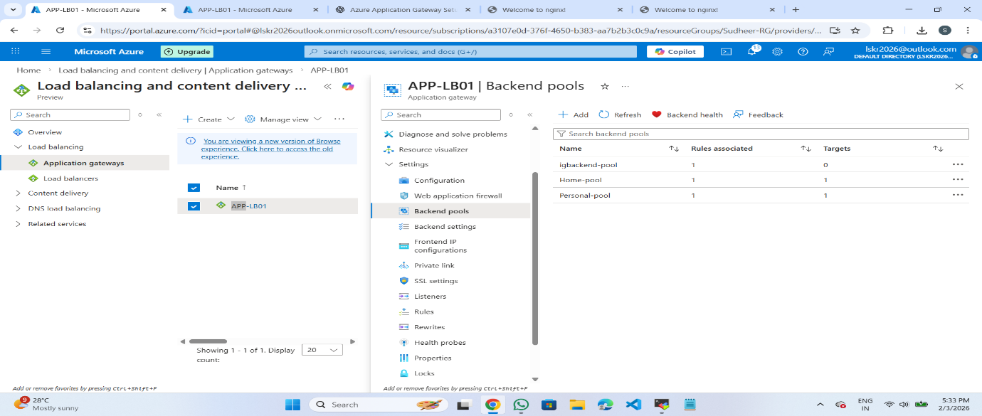
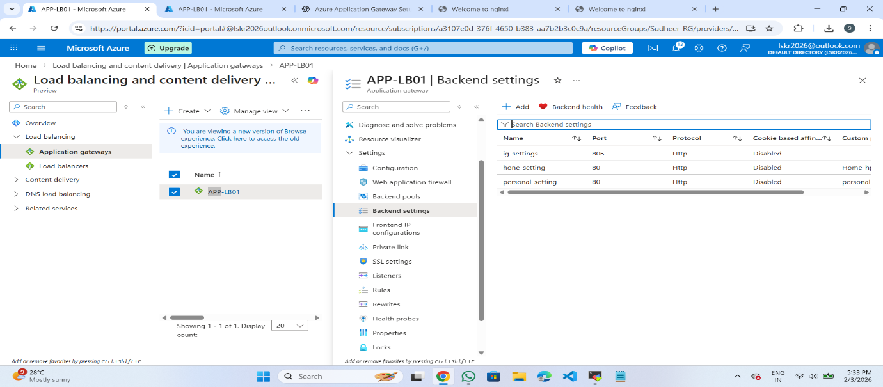
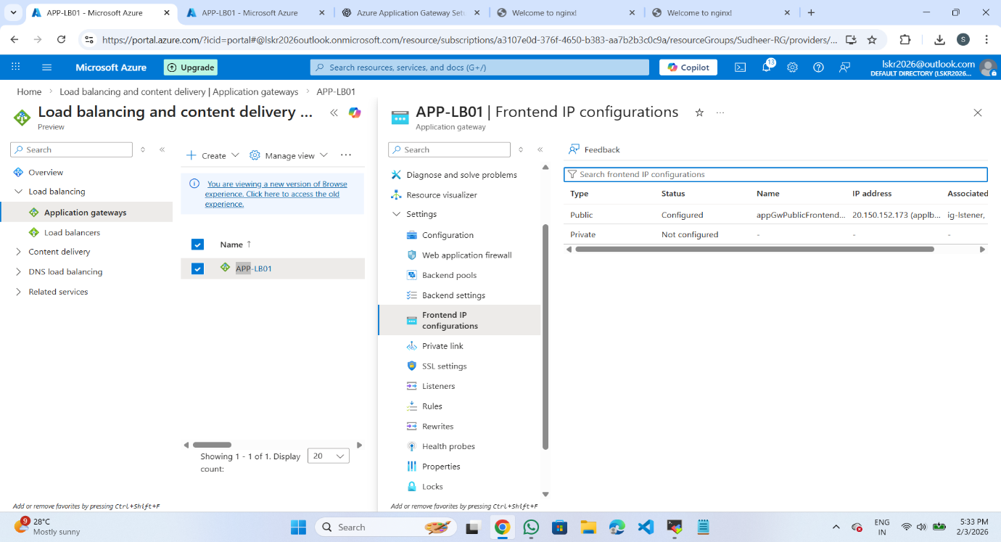

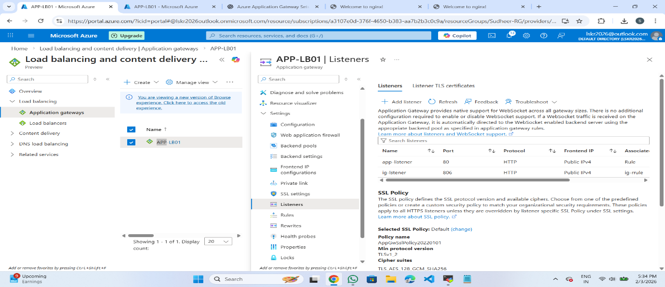
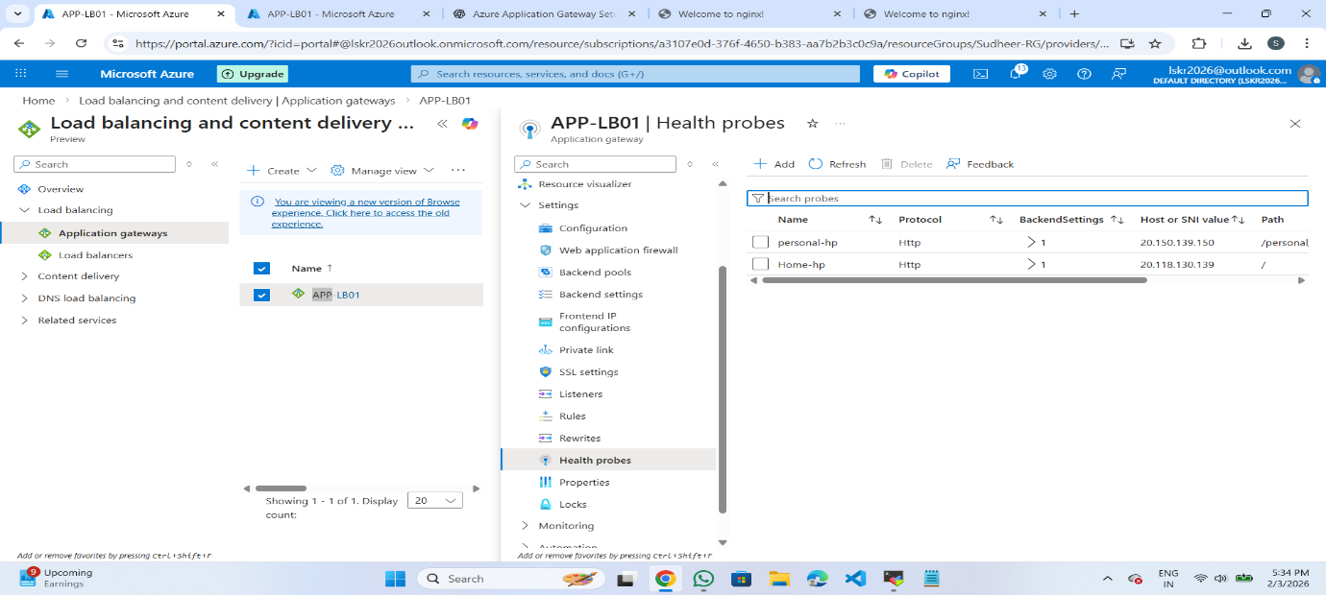
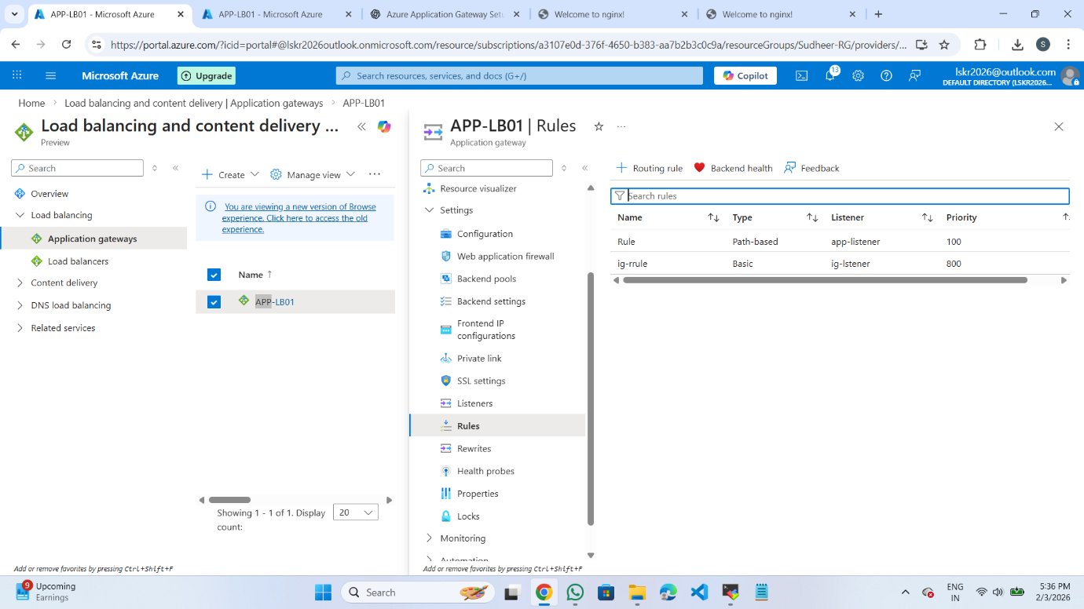
This is the final answer I got when I browse with application gateway id.


